**AIR QUALITY MONITORING USING IOT**

# TEAM MEMBER

**511821106001:AHMED SHARIFF A**

PHASE 5 PROJECT

Name of the project:

AIR QUALITIY MONITORING

OBJECTIVE:

The primary objectives of air quality monitoring in IoT (Internet of Things) are to collect real-time, accurate data on air pollutants, provide early warnings and alerts, ensure data accessibility, and promote environmental health, public safety, and policy compliance.

DEVICE SETUP:

Air quality monitoring in an Internet of Things (IoT) device setup is a valuable application for tracking and analyzing the quality of air in a specific environment. It can be used in various scenarios, including smart homes, industrial settings, and urban planning. Here's a general overview of how to set up an IoT air quality monitoring system:

* Select Sensors: Choose appropriate air quality sensors to measure specific parameters such as particulate matter (PM2.5, PM10), volatile organic compounds (VOCs), carbon dioxide (CO2), carbon monoxide (CO), nitrogen dioxide (NO2), ozone (O3), and temperature/humidity.
* Microcontroller/Processor: Select a microcontroller or processor (e.g., Raspberry Pi, Arduino, ESP8266/ESP32) to collect data from the sensors and send it to a central server or display it locally.
* Power Supply: Ensure a stable and reliable power supply for your IoT device. Depending on the use case, this could be through battery power, solar panels, or a consistent electrical source.
* Data Collection: Set up the sensors to collect air quality data at regular intervals. Sensors may output analog or digital data, which the microcontroller can process.
* Data Processing: On the IoT device, process the sensor data as needed. You can calibrate the data, calculate air quality indices (AQI), and apply noise filtering or data smoothing techniques.
* Data Transmission: Send the processed data to a central server or cloud platform. Use secure communication protocols to protect the data in transit. MQTT, HTTP, or CoAP are common choices.

PLATFROM DEVELOPMENT:

Air quality monitoring in IoT (Internet of Things) platform development involves the integration of sensors, data collection devices, and communication technology to continuously assess and report the quality of the air in a given environment. IoT-based air quality monitoring systems typically comprise sensors that detect various pollutants such as particulate matter (PM2.5 and PM10), volatile organic compounds (VOCs), carbon monoxide (CO), nitrogen dioxide (NO2), and ozone (O3). These sensors collect real-time data and transmit it to a central platform through wireless or wired connections. The platform then processes, stores, and visualizes the data, making it accessible to stakeholders through web or mobile applications. The information generated by these systems helps individuals, communities, and governments to make informed decisions about air quality and take necessary actions to mitigate pollution and protect public health. IoT-based air quality monitoring platforms play a crucial role in environmental management and public awareness by providing accurate and up-to-date information on air quality.

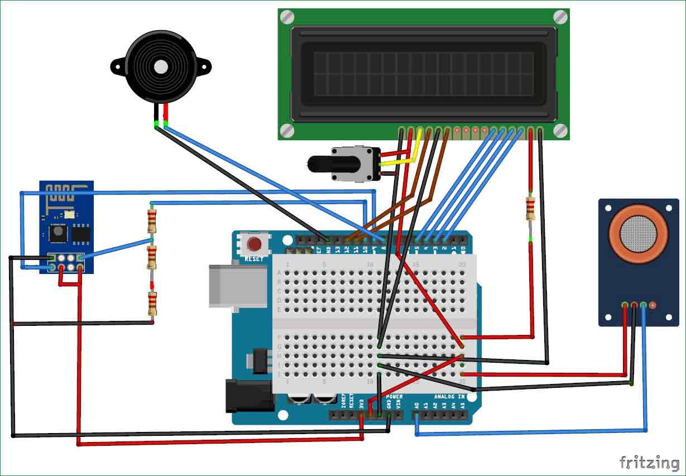

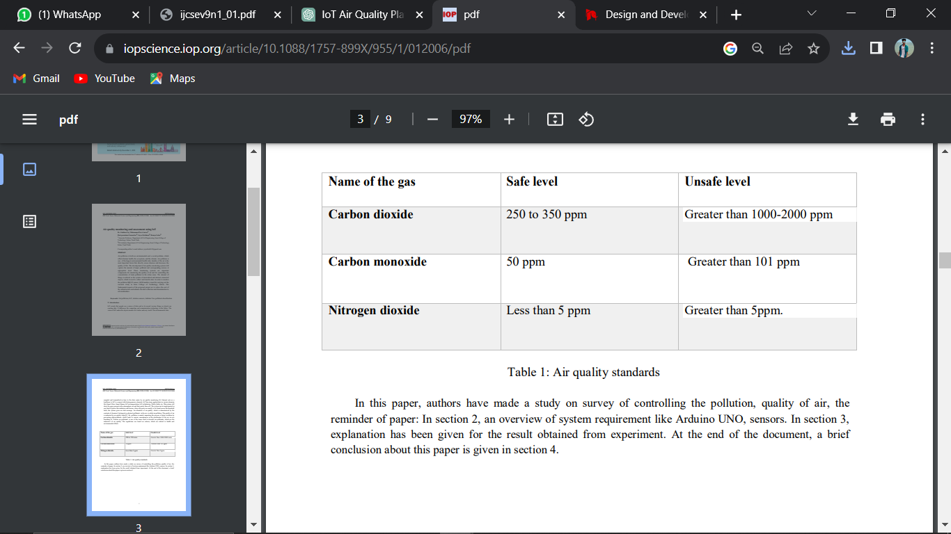

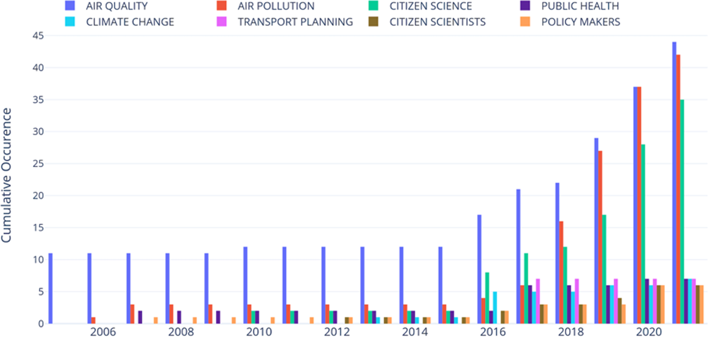

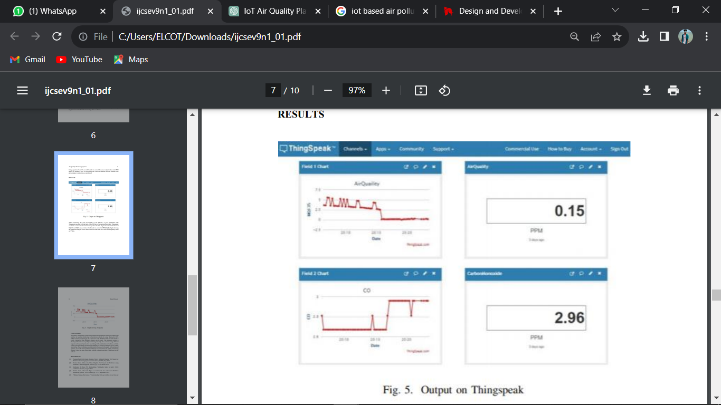

CODE:

# importing pandas module for data frame

import pandas as pd

# loading dataset and storing in train variable

train=pd.read_csv('AQI.csv')

# display top 5 data

train.head()

OUTPUT:

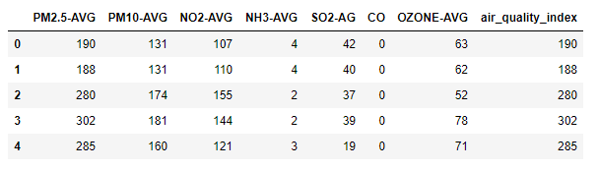

EXPLAINATION:

* IoT-based air quality monitoring is a system that leverages Internet of Things technology to continuously measure and evaluate air quality in different settings. It relies on specialized sensors that detect various air quality parameters such as particulate matter, gases, and environmental conditions. These sensors collect real-time data, which is then transmitted to a central hub or cloud-based server using wireless communication technologies. The central hub processes and analyzes the data, making it accessible through web-based or mobile applications, allowing government agencies, researchers, and the public to access and visualize air quality information. Data sharing and remote monitoring capabilities enhance transparency and informed decision-making, while historical data analysis helps identify trends and pollution sources. IoT-based air quality monitoring serves as a valuable tool for environmental management and public health protection.